Spade Portal
DevOps Platform
Nov 2016

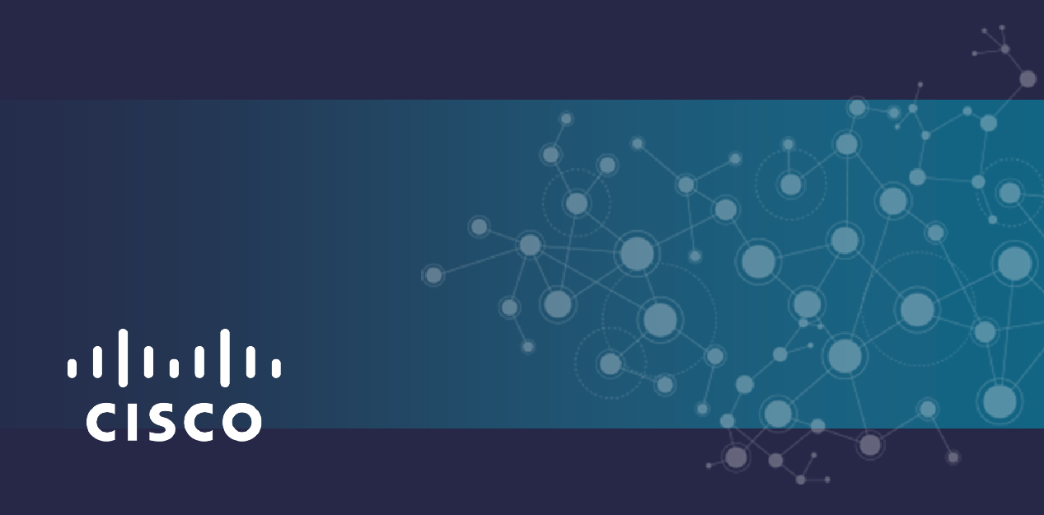
Table of Contents
Overview 1
Architecture 1
Authentication and Authorization Design 2
Portal UI 3
Database Model 3
WorkFlow and Agents Design 3
Activiti workflow daigram for project onboarding 4
Workflow description 4
API details for tool integration 6
Tools and Components Integration 6
UML model 6
Code Packaging and Deployment 6
Debugging 7

Overview
Spade Portal is a platform for one click onboarding of projects and users. Internal Cisco users as well as customers can access the portal to onboard the projects, view the executive summary of the projects health, state and various other analytical parameters of projects. For developers it acts as complete DevOps platform automating CI pipeline setup.

Architecture
Spade portal Client-Server architecture has been divided into 3 main components.
- Portal UI.
Angular 2 based UI and interface to REST web services. UI provides users and customers onboarding interface and provides the dashboard for various project specific parameters.
- WebServices Framework and Database
Jersey based REST framework which has both REST client and REST server implementations. Provides REST server interfaces to Portal UI components while has REST client implementations for DevOps tools interfaces, database and workflow engine interfaces.
- WorkFlow Engine and Agents
Activity based engine interfacing with DevOps tools through REST apis. While workflow engine maintains the workflow states for projects, agents are interface to the DevOps tools to do onboarding.

Please see Diagram 1 showing architecture.

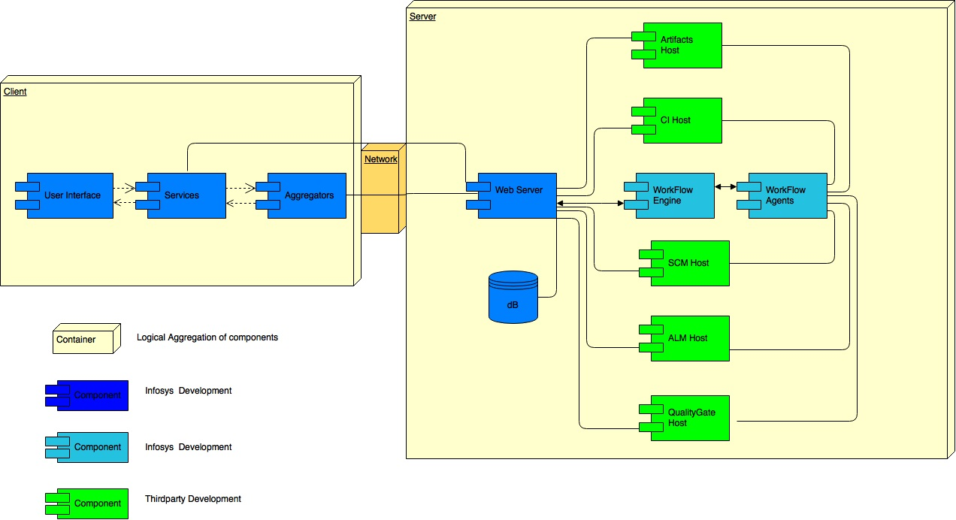
Diagram 1

Authentication and Authorization Design
- As per Cisco applications authentication is going through Cisco SSO.
- Authorization is done by portal.
- Portal queries the details for the user logged in from central database. Role, ViewID etc.
- Based on database population user specific view will be shown.
- Database is populated for roles from AD.

Portal UI
It is Angular2 based frontend. UI page separate mockup is created. Please refer to Mockup document.
https://rally1.rallydev.com/slm/attachment/78339203076/Cisco-SPADE-v1.pdf
User Interfaces and visualizations of the Portal can be classified into two main categories
- Onboarding
- Dashboards
Onboarding category provides users interfaces to onboard projects and users onto DevOps tools Rally, GitHub, Jenkins, Sonarqube, Artifactory. Onboarding details are captured in mockups.
Dashboards can be default dashboards provided by tools or the custom dashboards. As of writing Rally dashboards are considered. Clicking on dashboards icon will redirect to Rally to show custom dashboard in first phase.

Database Model
Database used is PostgreSQL, central database which is the only source of persistent data across portal operations. Please refer to Database Design document for details.
https://rally1.rallydev.com/slm/attachment/78803410416/SPADE%20DB%20Model.pptx

WorkFlow and Agents Design
Activity Engine is used for Workflow. Project onboarding workflow is managed by activity with its own database managing the workflow states. Please refer to design document for details. Agents are the wrapper between the Activity workflow engine and the DevOps tools. All the REST API requests of various tools for onboarding goes through the agents. User onboarding workflow can be managed in similar ways as the project onboarding.

Activiti workflow daigram for project onboarding

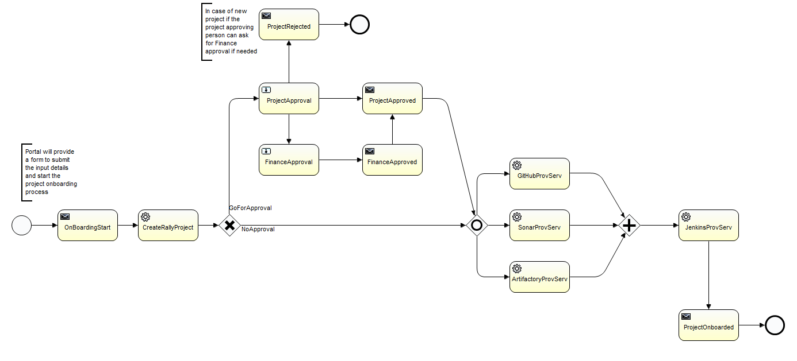

Workflow description
When a user submit a project onboarding request every time a new process instance will be started with the user attributes provided in onboarding form.
Following are the steps of workflow:
- On the start of process, a mail will be sent out to the project owner(s) notifying the onboarding process has been started.
- Rally Agent will be triggered and Rally agent will do following:
  - Send out a mail notifying the rally provisioning for project onboarding is started.
  - Validate if the specified workspace exists or not
  - Validate if the specified parent project exists or not
  - Validate if the specified project already exists or not
  - create a project under the selected technology/domain and parent project.
  - Specify the owner of the project.
  - Send out the notification for completion of rally provisioning.
- Depending on the attributes for approval steps will be triggered. If the attribute is yes then a user activity will be created for project approval, this user activity can be assigned to a user group/list of users. If the project approving authority think that this project need finance approval, then he/she can update the attribute as ‘finance’ and complete the work item. This will trigger the finance approval. In case it does not requires finance approval, authority can just update approved and complete the work item workflow will send out the approval notification and trigger the next step. If authority update the attribute as ‘rejected’ the project will be rejected. Even in case of rejection an email notification will be sent.
- Then Github, SonarQube and Artifactory agents will be triggered in parallel.
- Github Agent will do following:
  - Send out the notification for Github provisioning started
  - Check for the specified organization
  - Check for the specified repo
  - Check for the specified Technology/domain
  - Check for the specified parent project if any
  - Create a branch for the new project
  - Add a new folder for new project
  - Send out the notification for completion of Github provisioning
- SonarQube Agent will do following:
  - Send out the notification for start of provisioning
  - Create a project if required (Not in scope)
  - Create dashboards if required (Not in scope)
  - Send out notification for completion
- Artifactory Agent will do following:
  - Send out the notification for start of provisioning
  - Create a project directory structure if required (Not in scope)
  - Send out notification for completion
- Then Jenkins Agent will be triggered, it will do following:
  - Send out the notification for start of provisioning
  - Create a create a Jenkins job from the template job for the specified technology/domain.
  - Associate github
  - Associate SonarQube
  - Associate Artifactory
  - Send out notification for completion
- Send of the project onboarding completion notification to project owner(s) with the details of project and tools specific urls
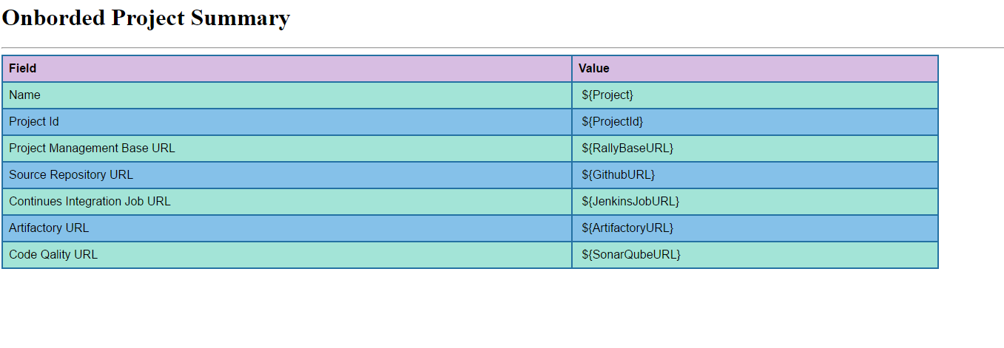

API details for tool integration
APIs used by Web Services Framework and the Workflow Agents to interact with various tools are attached verified. Please refer to APIs and verification details.
https://rally1.rallydev.com/slm/attachment/78077648560/APIFeasibility%201.0.xlsx

Tools and Components Integration
Details of various tool integration points
- DevOps Tools
DevOps tools are integrated to WebServices Framework through Jersey REST clients and to Activity workflow engine through Agents.
- WebService Framework
Web service framework exposes REST services which would be called from Portal UI.
- Database
Database queries are part of WebServices framework. Central database would be accessed through JDBC.

UML model
Component diagram is shown in Diagram 1.

Code Packaging and Deployment
Code packaging consists of
- Portal UI
  - Angular 2 based project.
  - A war file to be created as part of a Jenkins job that can be scheduled to run at specified time or can be triggered.
  - Apache Tomcat or the http server infrastructure of Cisco can be used. Load balancing to be taken care by Cisco infrastructure which is not scope of this document.

- Web Service Framework
  - Jersey framework
  - A war file to be created as part of a Jenkins job that can be scheduled to run at specified time or can be triggeredActivity and WorkFlow Engine
  - Integration with Tomcat/Cisco provided http server for serving web services

- Database
  - MySQL maintained by Cisco IT
  - Interfaced to web services as a datasource.

- Workflow engine
  - Activity
  - A war file consisting of workflow engine and agents that can be deployed through Jenkins job at specified time or when triggered
  - Integration with central database through datasource exposed by server hosting database

Debugging
- A development environment setup would be used to debug issues.
- Production environment can be with logging disabled
- In built logging framework would be used for Ex. LOGGER framework for Java components, Angular-2 Logger for typescript code. No central logging mechanism for client and server components

